# JOLT transform!

**Shift Operation in Jolt**

**One to One**

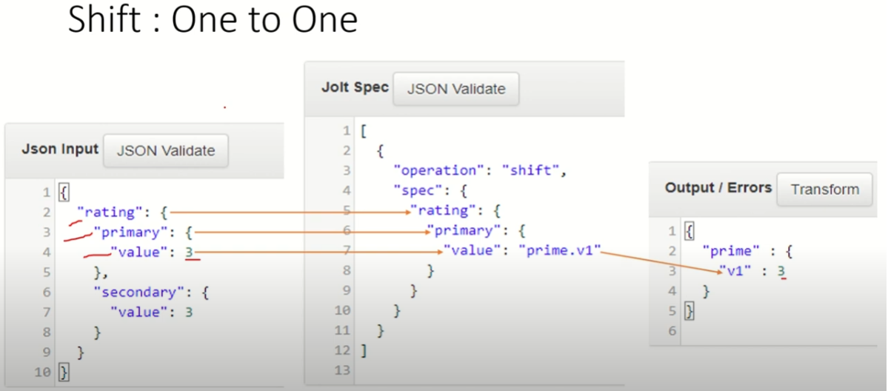

**One To Many**

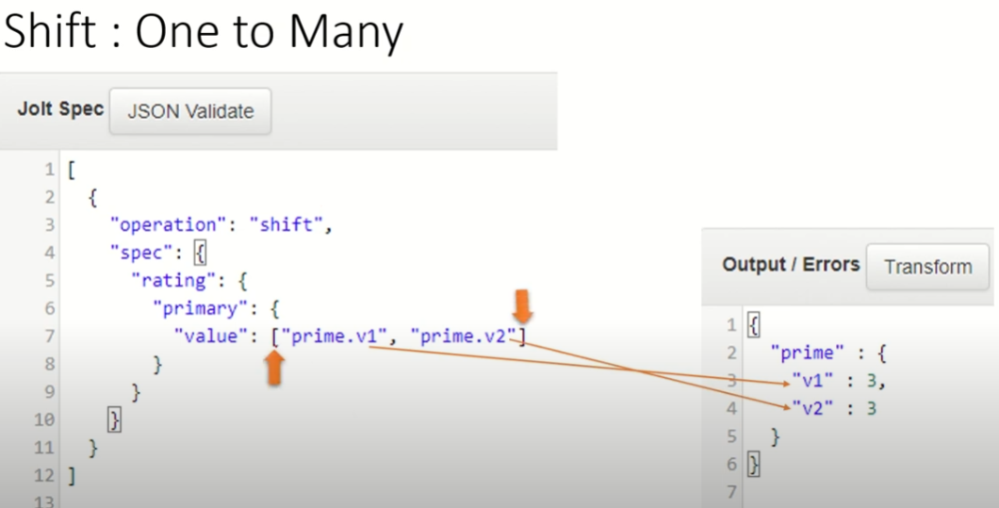

**In Array**

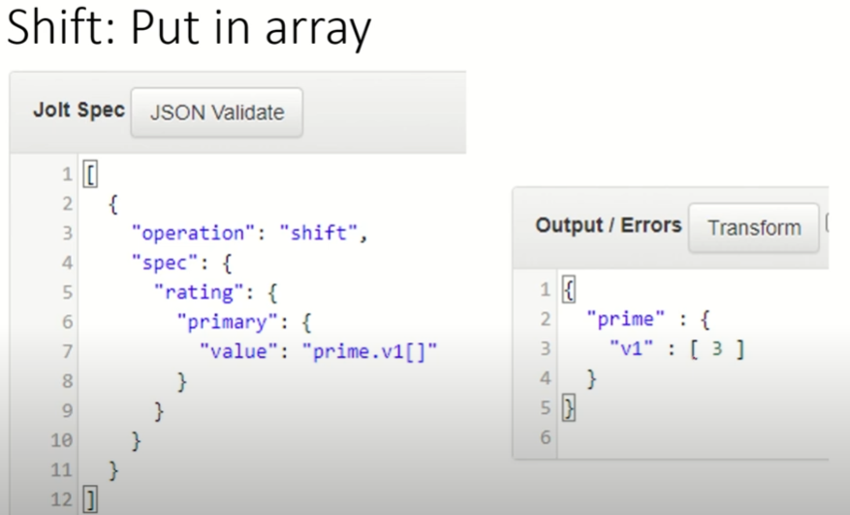

**In Array In Specific Index**

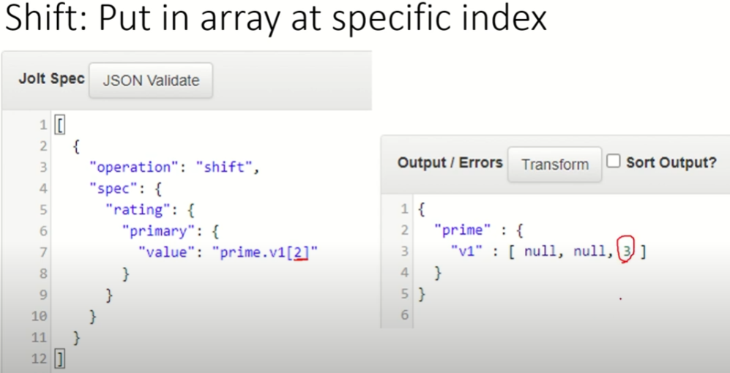

**Special Chars '&' in Jolt Spec**

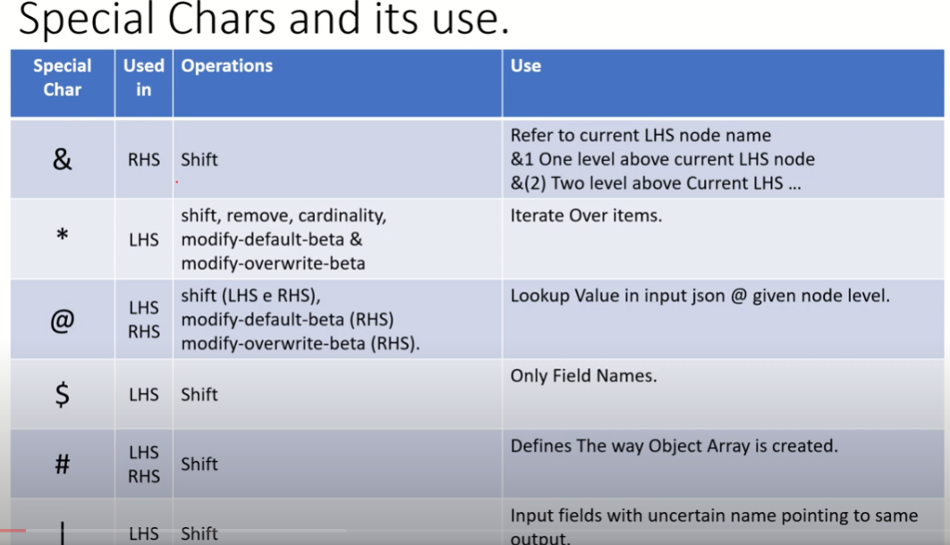

**&- The Node Name**

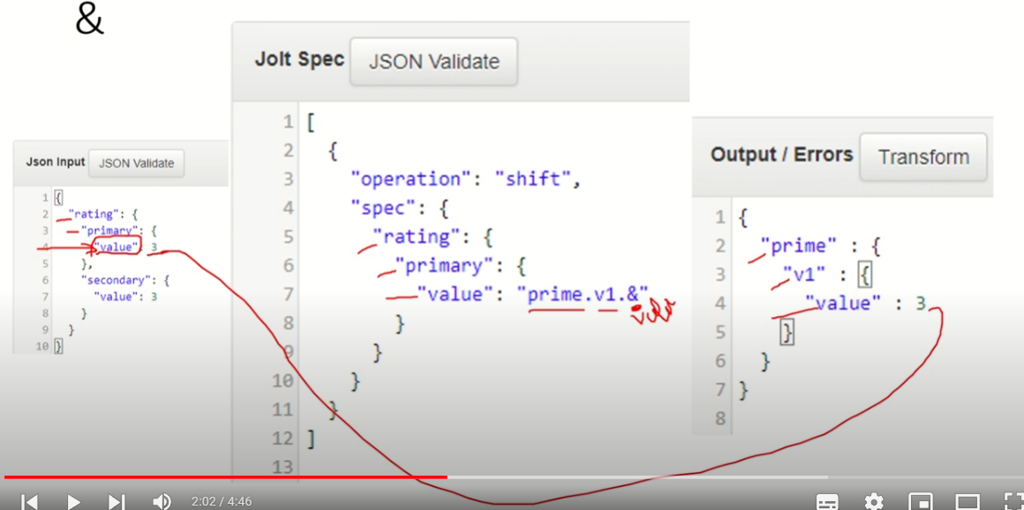

**&- The Node Name with index (n) n- level of jolt pointer**

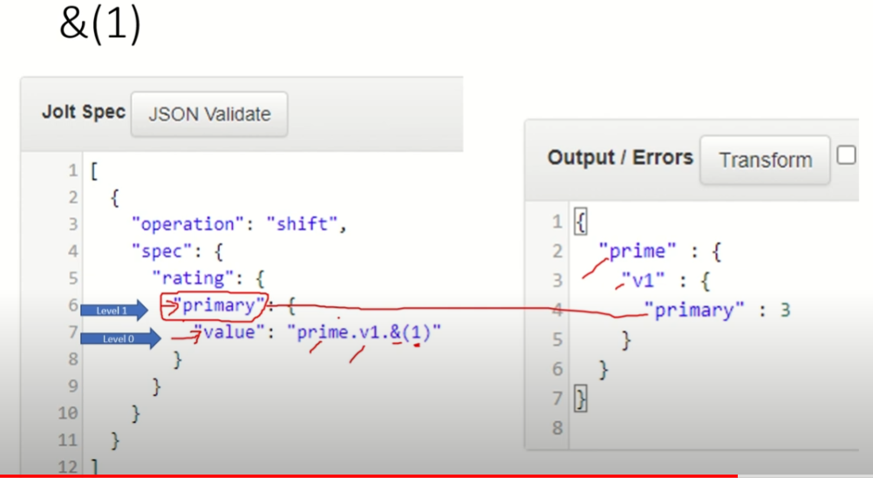

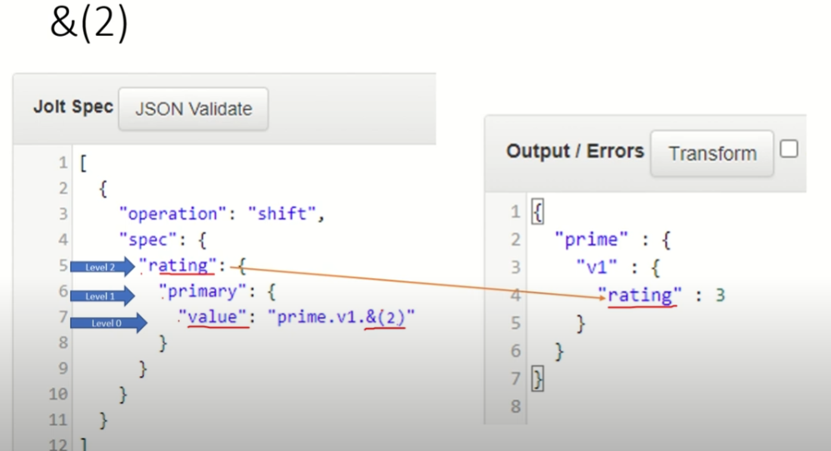

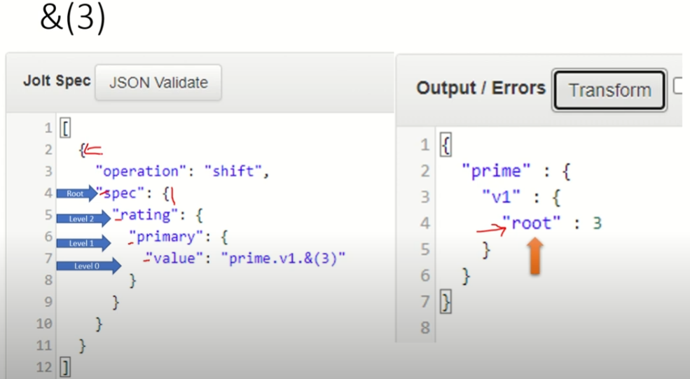

**Special Chars Asterisk '*' in Jolt Spec**

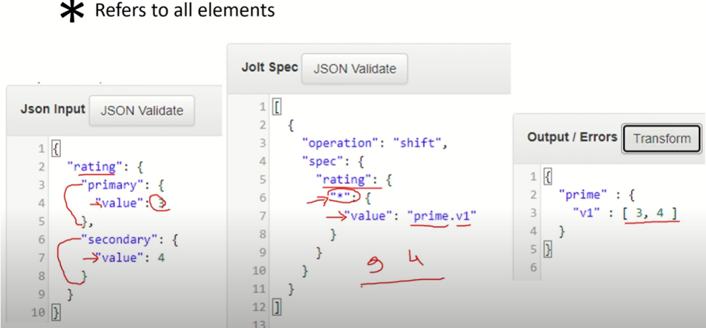

**\* with &**

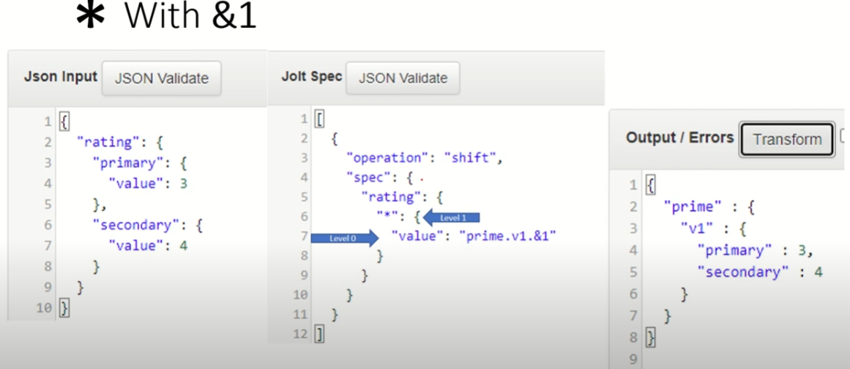

**\* with & 1**

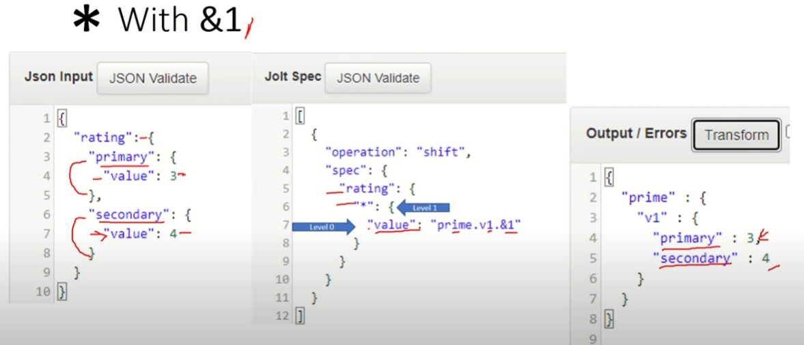

**\* with & 1 with prefix**

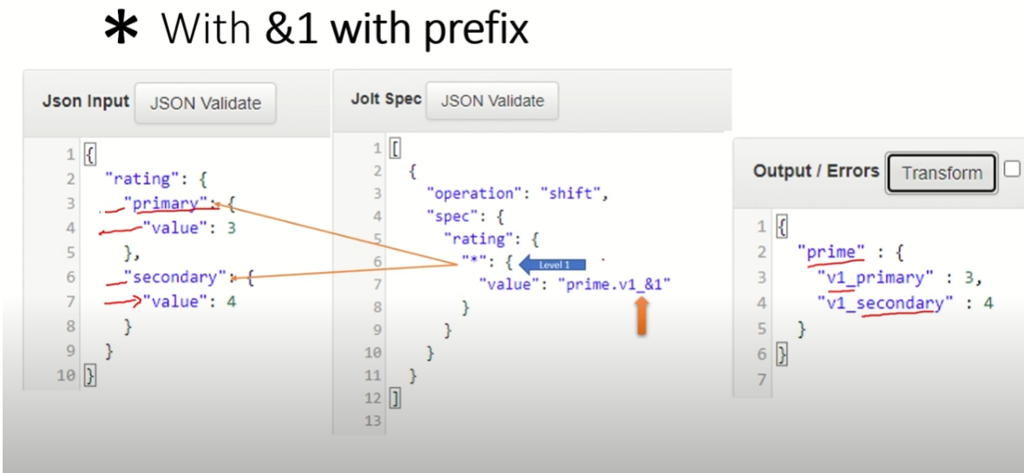

**Special Chars Asterisk '@' in Jolt Spec – Look for particular field on particular value**

**\* with & 1 with prefix**

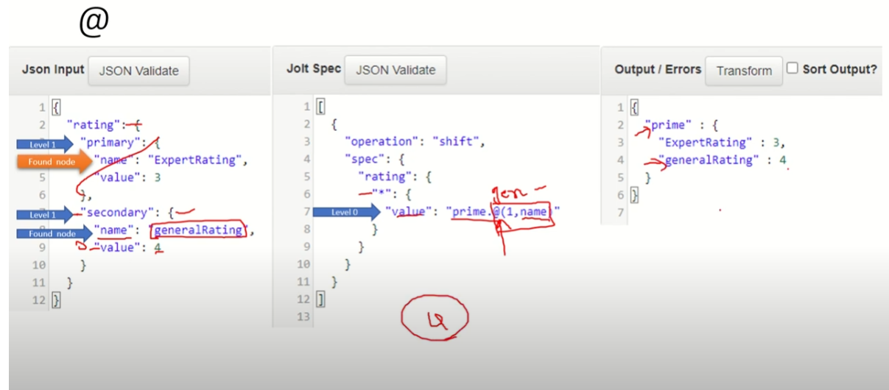

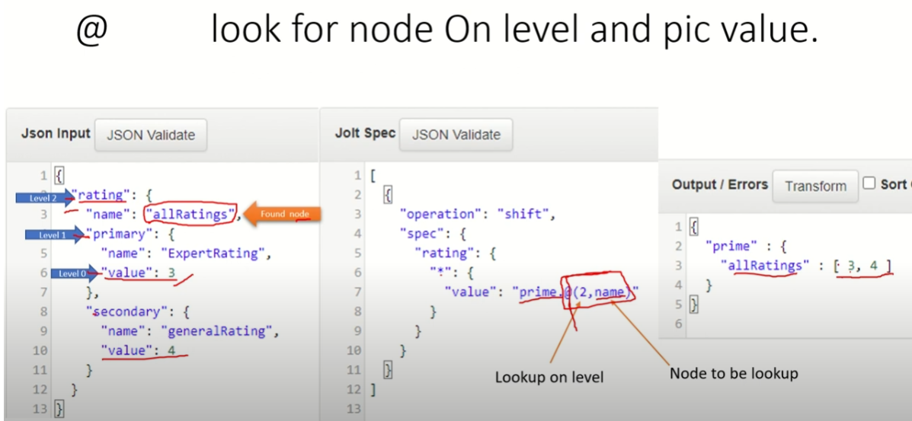

**Special Chars Asterisk '$' in Jolt Spec – Pick up all names (nodes) in the given level**

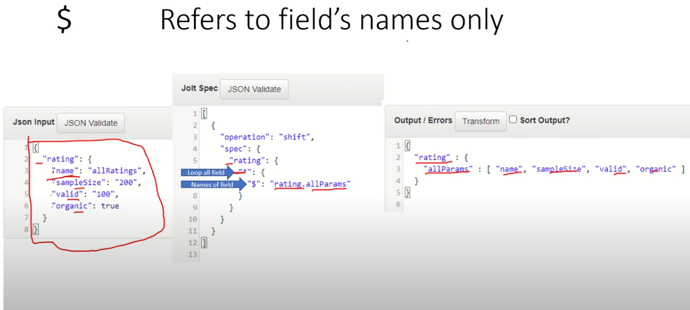

**Special Chars Asterisk ‘#' in Jolt Spec –**

**In LHS # - Default Value – Copy paste**

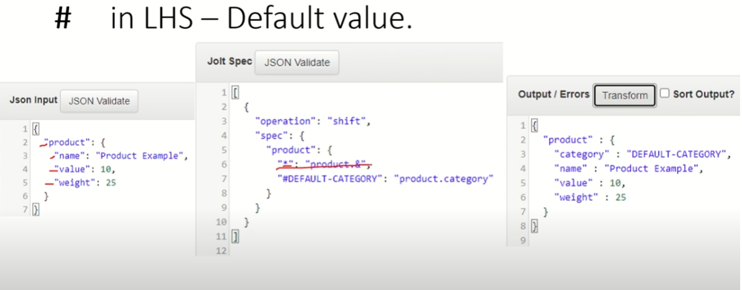

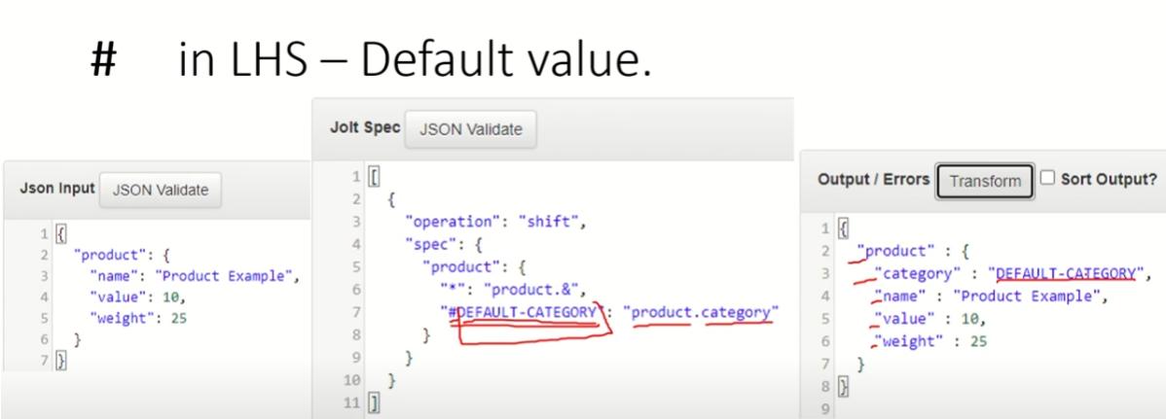

**# - Comparison of 0, 1, 2 positions – How objects are created**

**In #0**

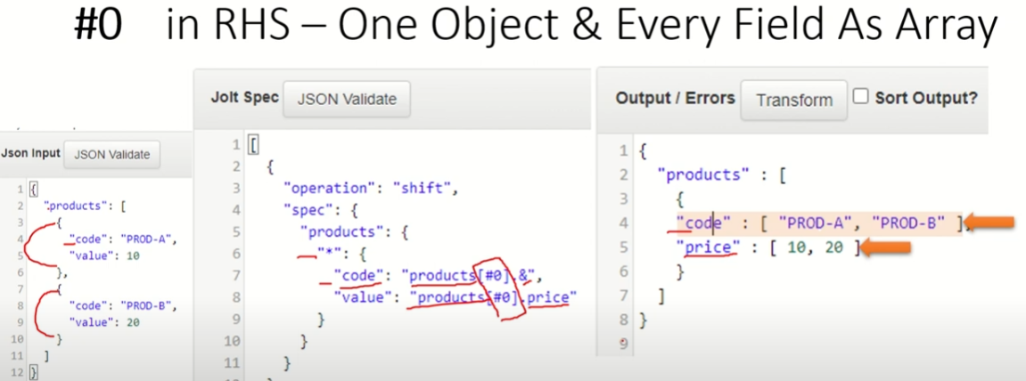

**In #01**

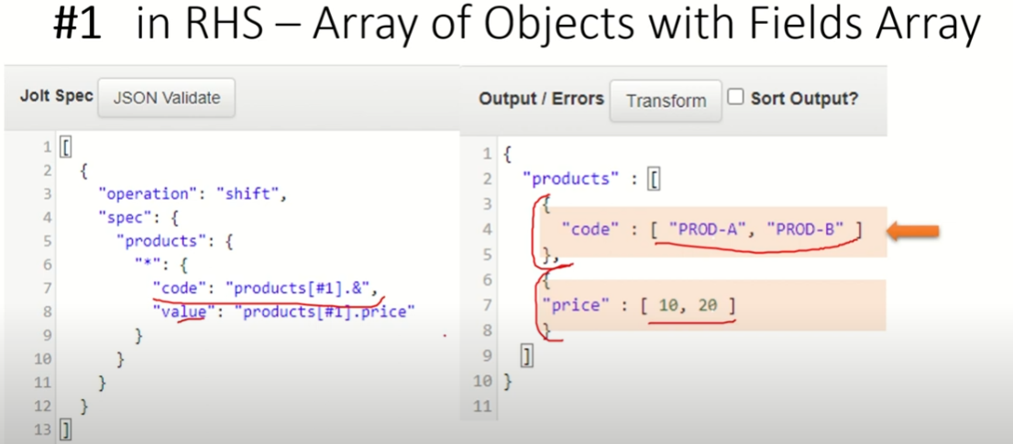

**In #2**

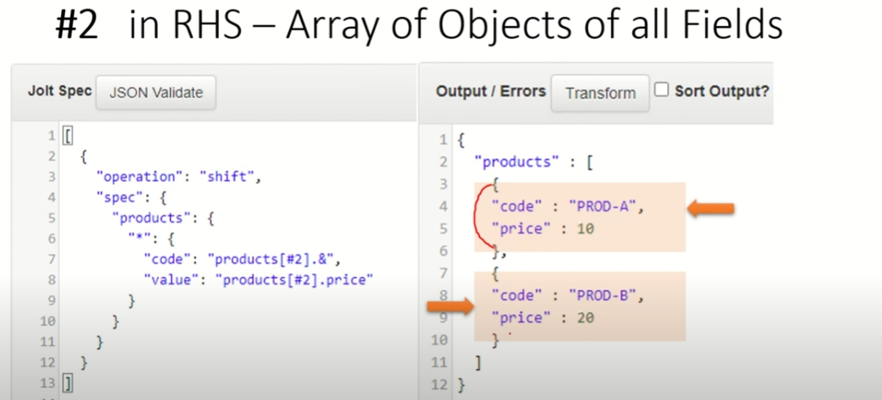

**Comparison of #0, #1 & #2**

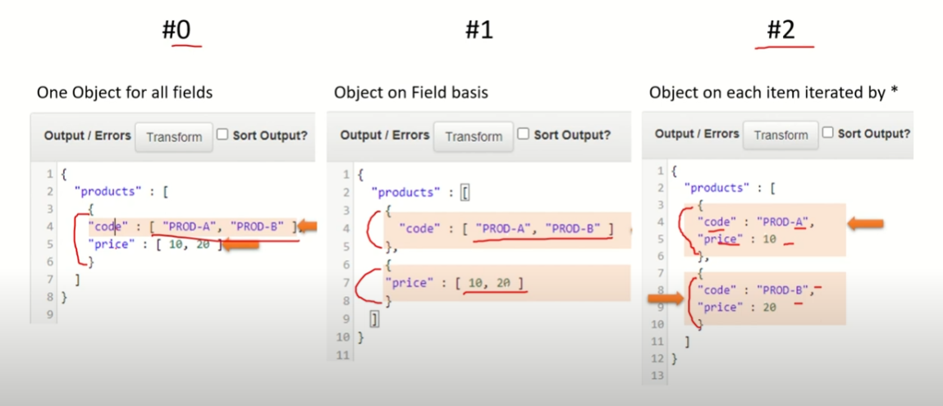

**Special Chars Pipe ‘|' in Jolt Spec – When Input filed not sure (any ranges)**

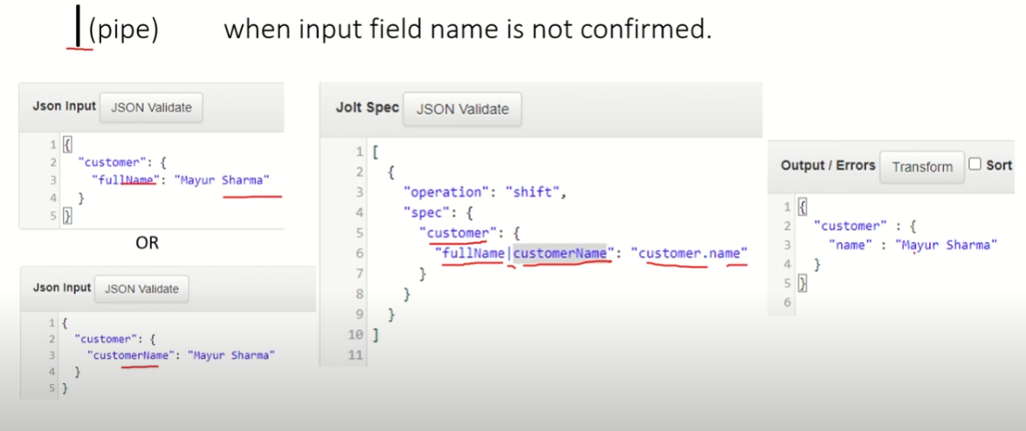

**All Special Chars Summary**

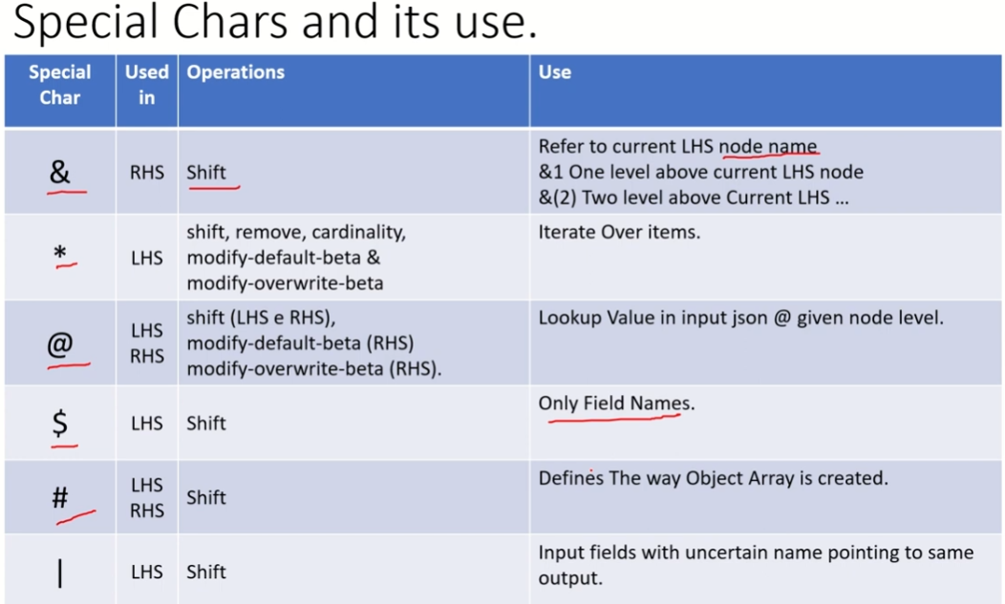

**Operation Remove**

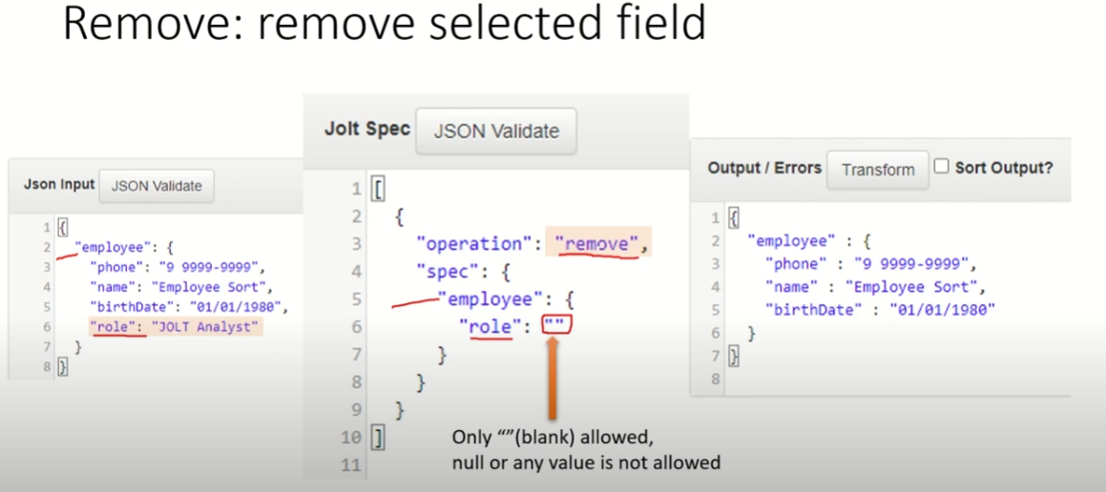

**Operation Chaining – Transform Back to Back**

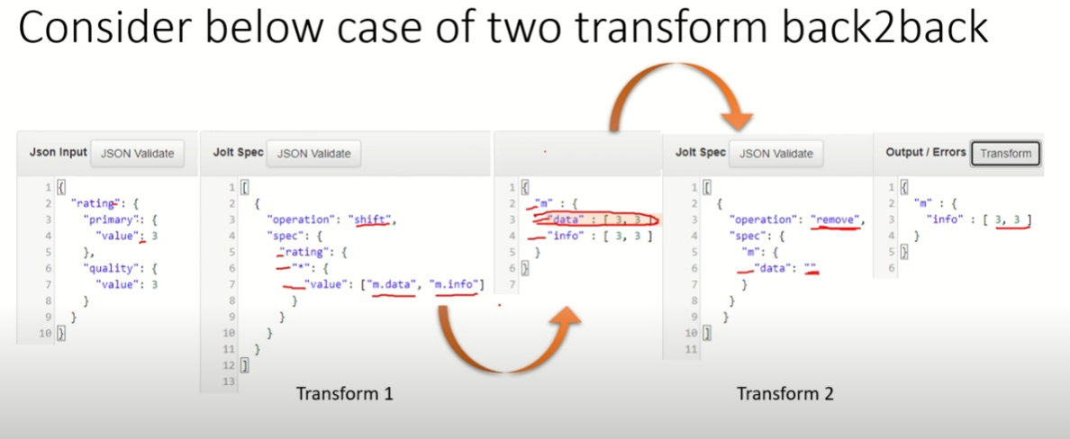

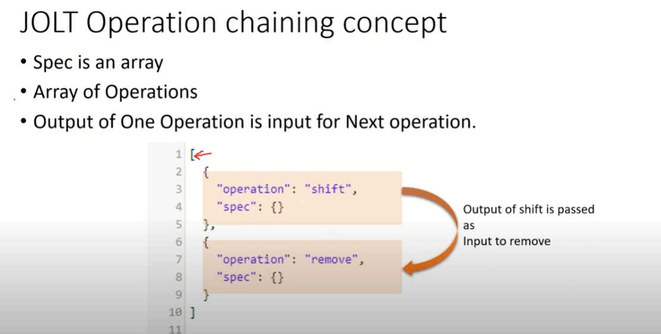

**Operation Cardinality – Transform Object to Array & Viceversa**

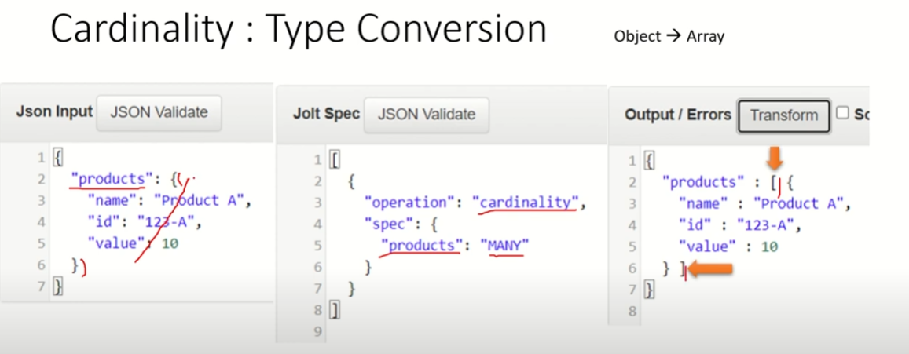

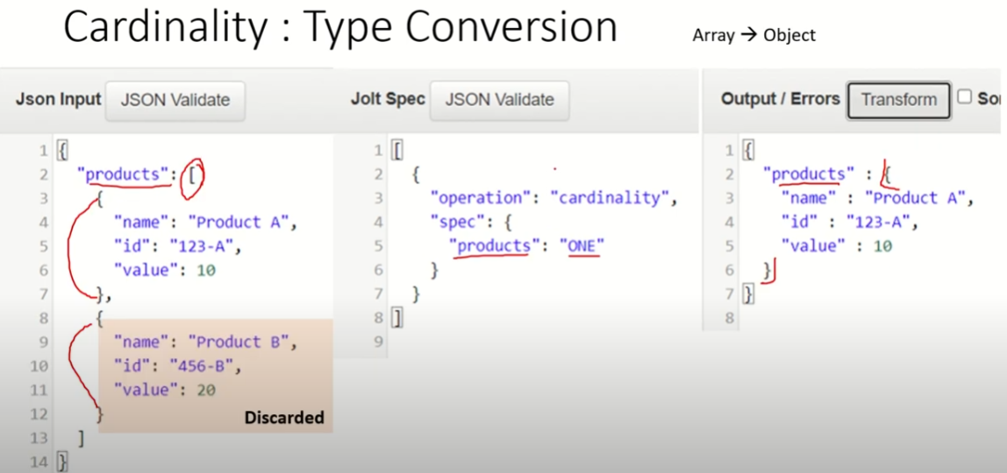

**Operation Sort – Sort in alphabetical order**

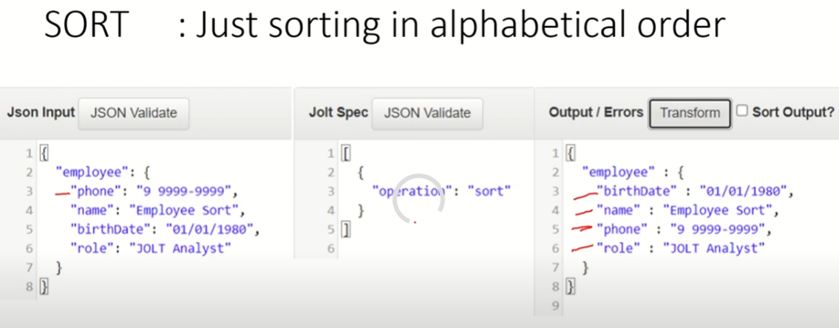

**Simple IF Else**

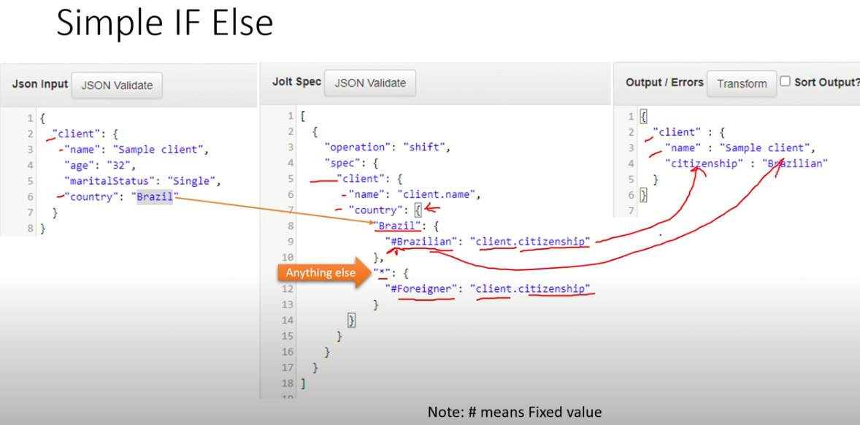

**Add New Value – Modify-overwrite-beta**

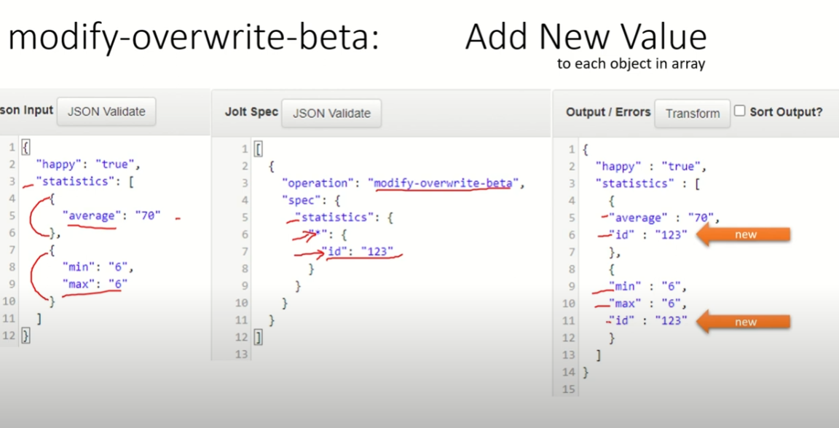

**With dynamic values**

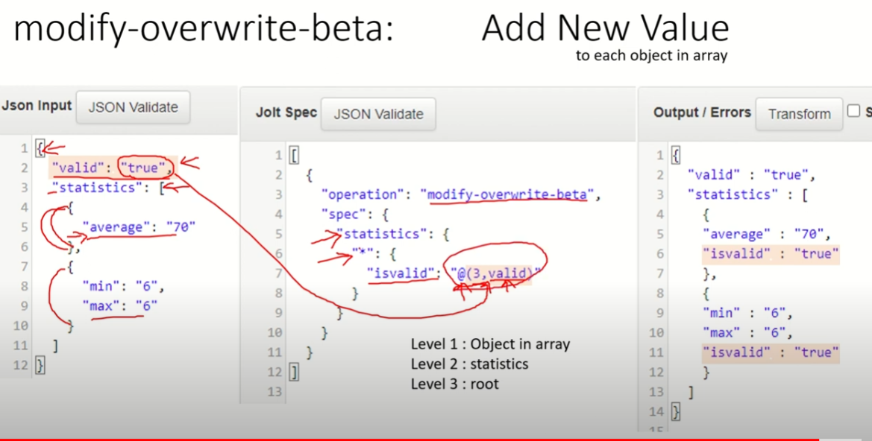

**Remove Null on same level – Modify-overwrite-beta - squashNulls**

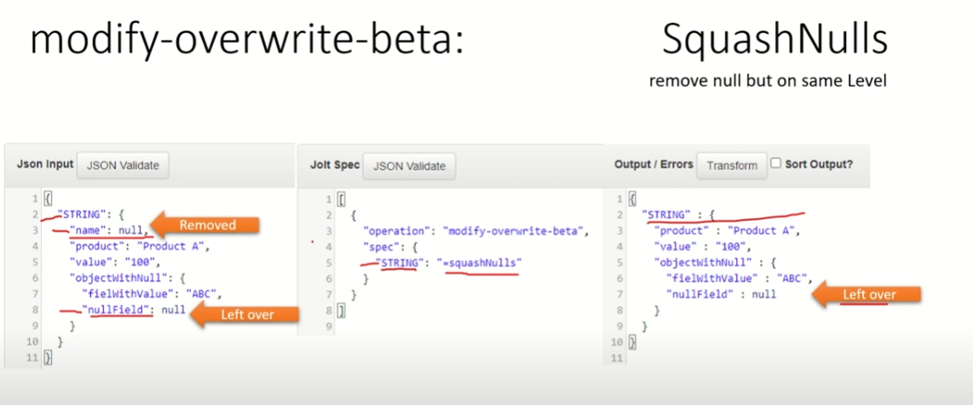

**Remove Null on all levels – Modify-overwrite-beta – recursivelySquashNulls**

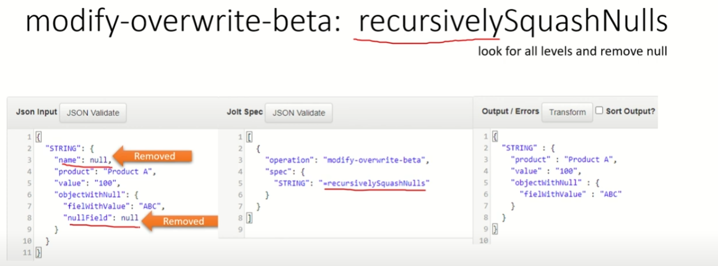

**Type Conversion – Modify-overwrite-beta – use function like syntax**

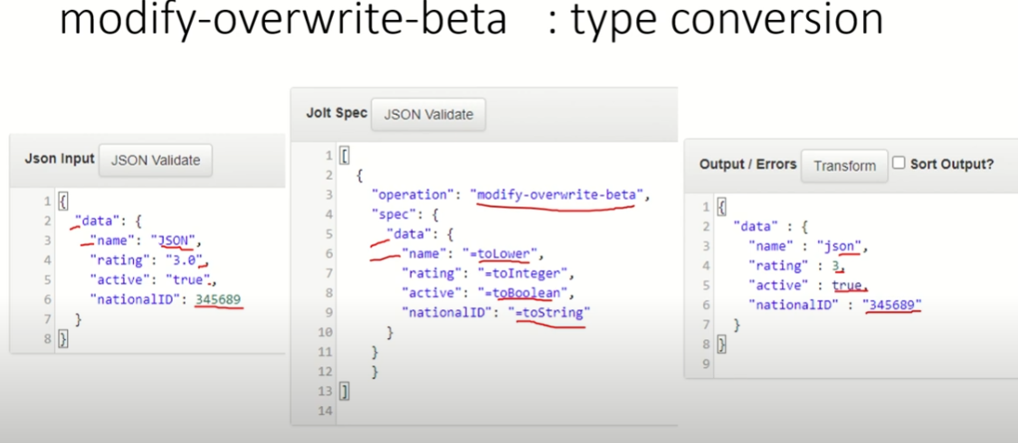

**Shift – operation # and &**

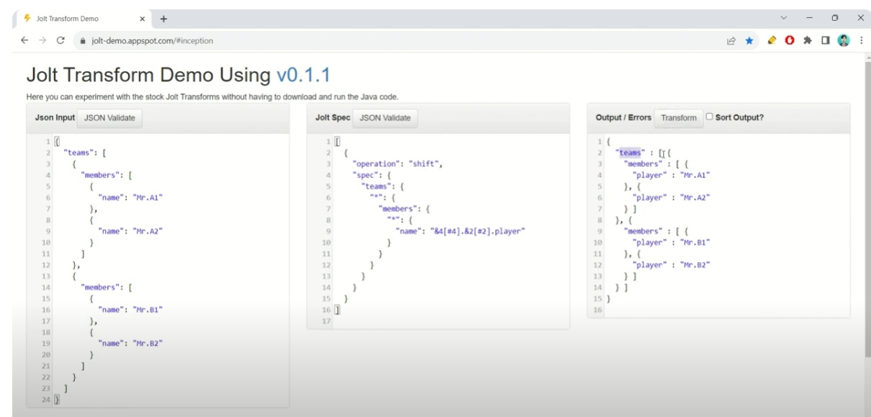

**Shift – operation – One to One**

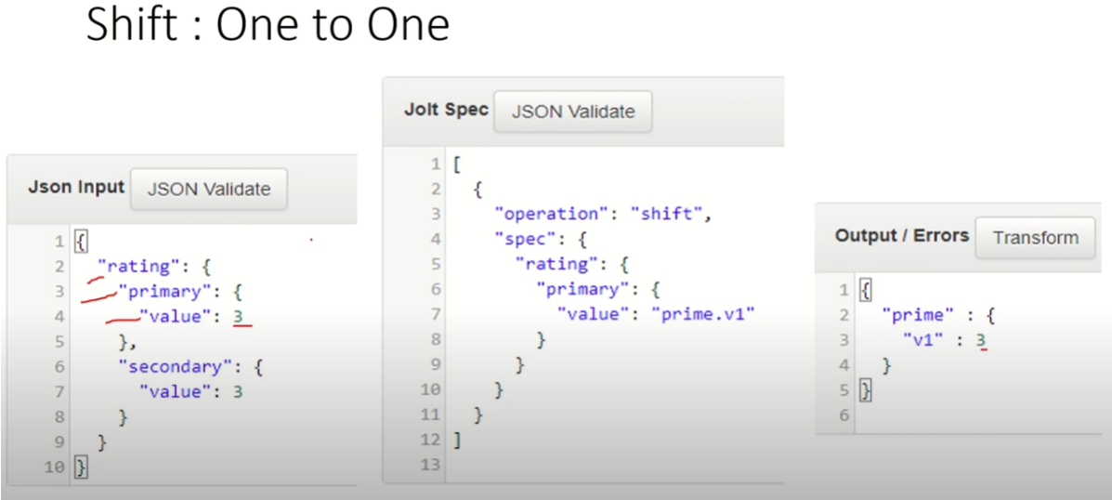

**Shift – operation – One to Many**

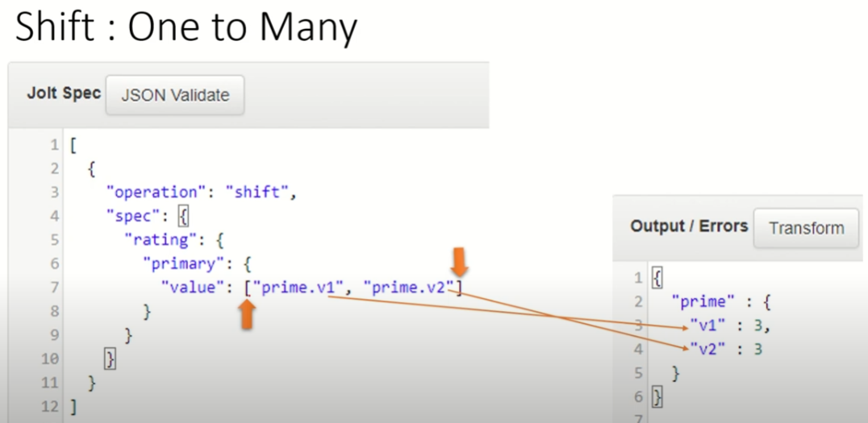

**Shift put in array**

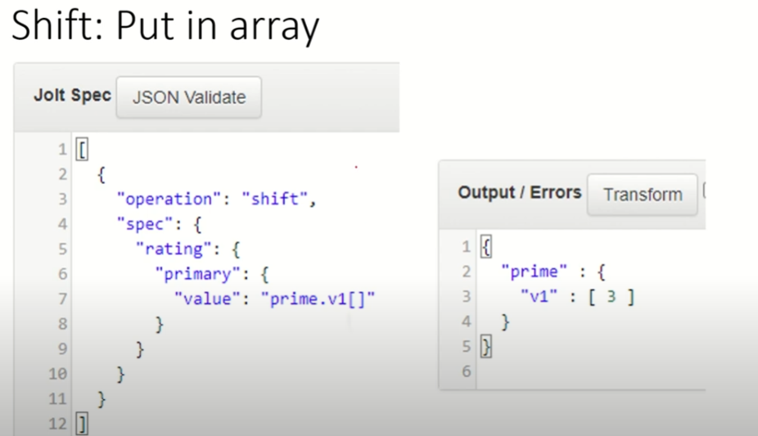

**Shift put in specific index**

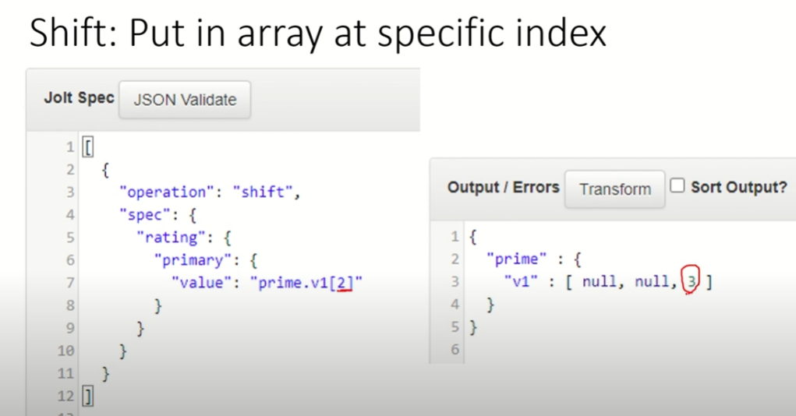

**Chat GPT for getting spec**

